Department of Computer Science and Engineering  
The University of Texas at Arlington

The Builders Group Ltd.

Sliding Profiler

Team Members:

Chudamani Aryal

Lloyd Bond

Jefferson White

Tyler Buchanan

Late Updated: 9 August 2012 @ 2:34:00 PM

Table of Contents

1 General Organization 1

1.1 Project Manager 1

1.2 Project Oversight 1

1.3 Roles and Responsibilities 2

1.4 Project Constraints 2

1.5 Project Assumptions 2

1.6 Preliminary Schedule and Cost Estimates 3

2 Scope Statement 4

3 Cost Management Plan 5

3.1 Labor Management 5

3.2 Material Management 6

4 Earned Value Management 7

5 Scope Management Plan 9

6 Work Breakdown Structure 10

7 Quality Management Plan 13

7.1 Overview 13

7.2 Roles and Responsibilities 13

8 Communications Plan 15

8.1 Summary 15

8.2 Internal Communications 15

8.3 External Communications 16

9 Change Management Plan 17

9.1 Purpose of an Integrated Change Management Plan 17

9.2 Roles and Responsibilities 17

9.3 Review and Approval Process 17

9.4 Change Identification, Documentation, Implementation and Reporting 18

10 Risk Management Plan 19

10.1 Purpose of Risk Management Plan 19

10.2 Roles and Responsibilities 19

10.3 Risk Identification 19

10.4 Risk Triggers 20

10.5 Risk Analysis 20

10.6 Risk Severity 20

10.7 Risk Response Planning 20

10.8 Risk Documentation and Reporting 21

10.9 Risk Control 22

11 Procurement Management Plan 23

11.1 Purpose of the Procurement Management Plan 23

11.2 Roles and Responsibilities 23

11.3 Required Project Procurements and Timing 24

11.4 Description of Items/ Services to be acquired 24

12 Project Closeout Report 25

12.1 The following are suggested sections for the Project Closeout Report: 25

12.2 Purpose of Closeout Report 25

12.3 Administrative Closure 25

# General Organization

## Project Manager

The team’s Project Manager is Chudamani Aryal who was selected for his project management experience. The Project Manager will work with team members to plan and organize the project activities. The Project Manager will also perform most of the administrative tasks including calling team meetings, setting the meeting agendas, and steering the overall group design process. The Project Manager will also perform work on team deliverables as necessary.

Chudamani may be reached at chuduz6@hotmail.com.

## Project Oversight

The project will have a bi-level oversight. Internal team controls shall be employed to monitor task-level and project-level status. These include the Work Breakdown Structure, Status Reports, Immediate Task Status Reporting and regularly scheduled meetings. This will serve as the first level of oversight designed to make fine-level adjustments. The Team Supervisor, Mr. O’Dell will serve as the second level of oversight at a course level of detail. The procedures for each level are as follows:

### Internal Status Monitoring

The following controls shall be employed to maintain a continual assessment of project status:

1. Work Breakdown Structure (WBS)
   1. All tasks, no matter how small or trivial will be entered into the WBS.
   2. The WBS shall be updated regularly (weekly, at least)
2. Status Reports – Weekly status reports
3. Immediate Task Status Reporting
   1. Completion of a task is communicated during the weekly meetings.
   2. Delay of a task is communicated immediately upon knowing to the project manager.
4. Team Status Meeting – Weekly (Tuesday and Thursday)
   1. Reviews all open, miscellaneous action items.
   2. Reviews tasks for the week

### External Status Monitoring

The team will provide Mr. O’Dell with status reports per the Summer CSE 4316 class schedule. Mr. O’Dell has specified that the team shall provide individual status reports and a team status update presentations.

## Roles and Responsibilities

There are various roles for individuals related to this project. These are distributed among the team members, the team supervisor, the project sponsor and the end-user liaison. These people are identified below:

1. Team Members
   1. Chudamani Aryal
   2. Tyler Buchanan
   3. Jefferson White
   4. Lloyd Bond
2. Team Supervisor – Michael O'Dell
3. Project Sponsor – Dr. Roger Walker
4. End- user Liaison – TBD (Dr. Roger Walker acting)

This team uses a matrix organizational structure. While the team uses a Project Manager position, the role is functional rather than administrative. Thus, the members of this team are organizational peers. In this manner, the structure is flat with accountability being to the project, the Team Supervisor and the Project Sponsor

Table – General Roles and Responsibilities

|  |  |  |
| --- | --- | --- |
| Role | Responsibilities | Assigned Personnel |
| Project Sponsor | * Provide high-level technical guidance * Provide team with product / project requirements * Clarify requirements as needed | Dr. Roger Walker |
| Team Supervisor | * Provide high-level guidance * Monitor team performance | Mr. Mike O’Dell |
| Project Manager / Team Lead | * Call all team meetings * Compile and publish meeting agendas * Record/publish the minutes of team meetings * Manage the development and maintenance of the Project Charter document * Manage the development and maintenance of the WBS * Develop team presentations * Determine and delegate project management tasks as necessary * Follow-up and report on delegated project management tasks | Chudamani Aryal |
| Requirements Manager | * Manage the requirements gathering and analysis activities of the team * Determine and delegate requirements management tasks as appropriate * Follow-up and report on delegated requirements management tasks * Manage the development and maintenance of the System Requirements Definition document (SRD) including versioning * Perform change analysis on requirements as needed * Report on the requirements gathering/analysis activities at team status meeting | Chudamani Aryal, Lloyd Bond, Tyler Buchanan, Jefferson White |
| Risk Manager | * Manage the risk management activities of the team * Determine and delegate risk management tasks as appropriate * Follow-up and report on delegated risk management tasks * Manage the development and maintenance of the Risk Management Plan section of the Project Charter * Perform change analysis on project risk as needed * Report on the risk management activities at team status meeting * Work with appropriate team members to develop risk mitigation strategies | Jefferson White |
| Research Manager | * Manage the forward-looking research activities of the team * Determine and delegate research tasks as appropriate * Develop and maintain a Knowledge Repository | Chudamani Aryal, Lloyd Bond, Tyler Buchanan, Jefferson White |
| Implementation Manager | * Work with appropriate team members to develop an implementation plan * Monitor, document and report implementation progress * Determine and delegate implementation tasks as appropriate * Identify and report implementation risks to the Risk Manager | Lloyd Bond, Tyler Buchanan |
| Change Manager | * Develop a comprehensive change management plan * Document the Change Management Plan in the Project Charter * Determine and delegate change management tasks as appropriate | Tyler Buchanan |
| Quality Assurance Manager | * Develop a comprehensive Quality Assurance (QA) plan * Document the QA plan in the Project Charter * Coordinate with architects, designers and the integration manager to develop appropriate QA tests * Determine and delegate Quality Assurance tasks as necessary * Monitor and report on the QA activities of the team | Lloyd Bond |
| Integration Manager | * Manage HW/SW integration * Schedule integration points | Chudamani Aryal |
| Budget Manager | * Work with appropriate members to develop the project budget * Develop and maintain the Budget Management plan section of the Project Charter document * Monitor the budget during the implementation phase of the project | Lloyd Bond, Chudamani Aryal |
| Procurement Manager | * Execute and follow-up on all approved procurement requests * Work with procurement requestors to find the best deals on procurements * Report all procurements to the Budget Manager | Lloyd Bond |
| Requirements Analyst | * Execute requirements gathering and analysis tasks as assigned * Meet with stakeholders as necessary to gather requirements * Provide requirements information to the Requirements Manager for documentation | Chudamani Aryal, Lloyd Bond, Tyler Buchanan, Jefferson White |
| Lead Architect | * Spearhead architecture effort by coordinating work with the Platform, Hardware and Software Architects * Manage development and maintenance of the Architectural Definition Specification (ADS) including versioning | Lloyd Bond |
| Platform Architect | * Develop the product’s physical platform architecture | Chudamani Aryal, Tyler Buchanan |
| Hardware Architect | * Develop the product’s hardware architecture | Lloyd Bond, Jefferson White |
| Software Architect | * Develop the product’s software architecture | Chudamani Aryal, Lloyd Bond, Tyler Buchanan, Jefferson White |
| Lead Designer | * Coordinate the detailed design efforts of the team * Manage development and maintenance of the Detailed Design Specification (DDS) including versioning | Jefferson White |
| Software Designer | * Design applicable software components as determined by the ADS | Chudamani Aryal, Tyler Buchanan |
| Hardware Designer | * Design applicable hardware components as determined by the ADS | Lloyd Bond, Jefferson White |
| Platform Designer | * Design applicable platform components as determined by the ADS | Chudamani Aryal, Lloyd Bond, Tyler Buchanan, Jefferson White |
| Software Developer | * Develop software components as assigned | Chudamani Aryal, Tyler Buchanan |
| Hardware Developer | * Develop hardware components as assigned | Lloyd Bond, Jefferson White |
| Platform Developer | * Develop platform components as assigned | Chudamani Aryal, Lloyd Bond, Tyler Buchanan, Jefferson White |
| Test Engineer | * Perform software, hardware and/or platform tests as assigned | Chudamani Aryal |

## Project Constraints

This project is part of the Senior Design capstone course at the University of Texas at Arlington. The Detailed Design, Product Development/Debugging and System Testing phases of this project will occur during the Fall 2012 semester. This constrains these phases to an eleven (16) week schedule.

The team is constrained to a fixed size of four members. Members will be able to provide varying levels of commitment to the project on a weekly basis due to other external obligations. This constrains the project to a fixed man-hour capacity.

## Project Assumptions

* Product will operate in all weather related conditions applicable for laying concrete.
* Product will be stored in varied temperature range.
* Product may be exposed to temperature extremes other than the above cases. E.g. Alaska(cold),Texas(hot).
* Product will be returned to an authorized maintenance authority for servicing (technician) and calibration (support-user).
* Product will not be serviced on location.
* Maintenance authorities (technicians) will have the means to properly test recalibrated Products before returning them to service.
* Power will be made available for the Product from the road paver.
* Product need only maintain a window of sensor history in memory to detect bumps.
* Product need not contain an audible bump indicator.
* Product will not have any sort of display other than indicator lights on the actual platform; all display will occur on a remote system.

## Preliminary Schedule and Cost Estimates

Given the constraints and assumptions indicated above, the following high-level overview of key checkpoints and dates was determined for this project. Project Cost is in order-of-magnitude for both man-hours and currency.

### Initiating Authority’s Checkpoints

Checkpoint Estimated Completion Date

Requirement Review Gate 24 July, 2012

Architectural Design Gate September, 2012

Detailed Design Review October, 2012

Test Plan Review November, 2012

Prototype Delivery December 2012

### Initial Project Cost Estimates

Personnel Resources 2000 man-hours

Hardware Resources $800

Software Resources NA

Our team has two possible cases of cost analysis. Case 1 assumes that partial components will be provided by Dr Walker and partial by Mr. O’Dell. The second case assumes that all the components will be provided by Mr. O’Dell. Components with low price of zero indicate that those components will be provided by Dr. Walker.

Table 2 – Cost Estimates: Case 1

|  |  |  |
| --- | --- | --- |
| Components | Low Price ($) | High Price ($) |
| Inclinometer | 0 | 900 |
| Temperature Sensors | 0 | 5 |
| Encoder | 0 | 5 |
| Microcontroller Unit | 0 | 5 |
| A/D Convertor | 0 | 250 |
| GPS | 40 | 100 |
| PCB + RS232 Interface | 15 | 35 |
| Network chip | 10 | 45 |
| SD Card | 3 | 20 |
| Enclosure | 0 | 50 |
| Platform | 40 | 150 |
| Distance Wheel | 0 | 20 |
| PC Client | 0 | 250 |
| Total | 108 | 1585 |

Table 3 – Cost Estimates: Case 2

|  |  |  |
| --- | --- | --- |
| Components | Low Price ($) | High Price ($) |
| Inclinometer | 900 | 900 |
| Temperature Sensors | 5 | 5 |
| Encoder | 5 | 5 |
| Microcontroller Unit | 5 | 5 |
| A/D Convertor | 5 | 250 |
| GPS | 40 | 100 |
| PCB + RS232 Interface | 15 | 35 |
| Network chip | 10 | 45 |
| SD Card | 3 | 20 |
| Enclosure | 30 | 50 |
| Platform | 40 | 150 |
| Distance Wheel | 15 | 20 |
| PC Client | 150 | 250 |
| Total | 1223 | 1585 |

# Scope Statement

The Sliding Profiler is a product originating with Dr. Roger Walker. Dr. Walker is the current patent holder for the sliding profiler. Dr. Walker holds this patent in the public domain for University of Texas at Arlington. It is University of Texas at Arlington’s goal to generate money from development of this product. The current version’s main use is to aid in the development of new roadways by ‘bump detection’. Texas Department of Transportation incentivizes with a bonus/penalty to encourage the attentive process of laying smooth roadways. The Sliding profiler system is very important to ensure the roadways produced, are as smooth as possible. The goal of this project is to design a model that is capable of use anywhere concrete can be laid for streets.

The current model consists of the following:

* Inclinometer
* Distance Encoder
* Heartbeat Light (to show that the program is up and running)
* Beacon Light (bump identifier)
* ON/OFF Switch
* Connections to External Power (provided by the client)
* Connections to Client PC
* Embedded PC
* Snowboard (platform)

The upgrade will feature

* PIC Microcontroller instead of an Embedded PC
* GPS location tracking
* More Friendly UI
* Improved platform (floating capability, light weight, better mechanical design)
* More tolerant components for extreme weather conditions applicable to laying concrete

# Cost Management Plan

Cost management plan is a major part of any project. It is a document which outlines the plan to stay within the budget. It includes how cost variances should be managed, if they occur. This document also ensures efficient use and allocation of the fixed resources. Our plan includes labor costs and material costs.

## Labor Management

This section shall look at how much time should be spent on specific portions of the project in order to achieve the most effective cost management for our product.

Our team consists of four members, two computer science and two computer engineer students. According to given information, our project shall take 2000-man hours. Our team approximated 500-man hours for Senior Design I and 1500-man hours for Senior Design II. We have 11 weeks for Senior Design I. This shall require us to work for 11.36 -man hours per week. And we have 16 weeks for Senior Design II. This shall require us to work for 23.44- man hours per week. This schedule shall help us to complete our project on time.

One of the important things to consider while managing team members is to make sure that nobody is over-allocated or under-allocated. The team leader has to make sure that every team member has his fair share of the work. However, it is not always possible to eliminate the possibility of over-allocation or under-allocation. Sometimes, a specific team member might be good at specific work-related tasks which others are not so good at. In that case, it is alright to over-allocate him. But, the team leader has to keep in mind that the same team member shall not be over-allocated for next assignment. Also, before allocating the work, it is necessary to go back and look at the individual assessment form. This form gives a clear idea about the strengths of the team as well as the strengths of the individuals. It informs the team which team member is good at what particular skills. By looking at this form, it is easier to assign work. Also, there were many things that were not included in the individual assessment form. Hence, it is important to talk among the team members about the specific task related skills which were not included in the assessment form.

Team meetings shall be conducted twice a week. Some of the generic agendas to the team meetings shall be status updates on given assignments, risk management evaluation, earned values, work outlook, internal and external deadlines. 2-man hours shall be allocated for team meetings each week.

Internal deadlines shall be set and a schedule shall be posted in the senior design lab. In case of unknown setbacks, internal deadlines shall give us an extra time to recover the team from those setbacks. The deadline shall also help us to focus on our work. It shall also give us enough time to compile all the work and make the complete work precise, correct, and consistent.

The factors considered while assigning tasks shall be knowledge of the specific skill, previous history of over or under allocation and individual/personal schedule.

## Material Management

This section shall look at how much capital shall be allocated for specific parts in order to achieve the most effective cost management possible for our product.

Our team has a maximum budget of $800. The purchase of material shall also be delayed until the completion of detail design of the product. By that time our team shall have a clear idea of the parts that shall be required to complete the project.

To ensure that the budget is utilized efficiently, the purchase order must be finalized and approved by the Team Supervisor, Mr. O’Dell. Any changes to the purchase orders must also be approved by Mr. O’Dell.

To reduce the cost of the project, our team shall utilize any re-useable materials found from previous senior design projects. Also, our sponsor, Dr. Walker, is willing to provide materials from his previous sliding profiler projects. While utilizing used parts (or maybe new parts), it is our responsibility to make sure that they work properly.

If over-budget, the team shall try to buy less-expensive materials. If still over-budget, the team shall redesign our product.

## Cost Management Roles and Responsibilities

Table 4 - Cost Management Roles and Responsibilities

|  |  |  |
| --- | --- | --- |
| Role | Responsibilities | Assigned Personnel |
| Project Sponsor | * Approve budgets over $800 * Assist in securing necessary funding outside of in-class budget | Dr. Roger Walker |
| Team Supervisor | * Approve budget under $800 | Mr. Mike O’Dell |
| Budget Manager | * Work with appropriate members to develop the project budget * Develop and maintain the Budget Management plan section of the Project Charter document * Monitor the budget during the implementation phase of the project | Chudamani Aryal, Lloyd Bond |
| Procurement Manager | * Report completed purchases to Budget Manager | Lloyd Bond |
| Lead Architect | * Work with Budget Manager to develop the product’s capital expense needs | Lloyd Bond |
| Project Manager | * Work with Budget Manager to develop the project’s personnel budget needs | Chudmani Aryal |

# Earned Value Management

Earned Value, also referred to as the budgeted cost of work performed (BCWP), is a useful tool that will be utilized throughout this project in order to provide numerical measurements to help track the schedule and budget of the project. To make these measurements useful, the earned value will be compared against separate measurements for actual cost of work performed (ACWP), and budgeted cost of work scheduled (BCWS). The units of measurement used to track the budget of the project are man-hours.

## Measurement:

All data required for Earned Value Management will be tracked in a Microsoft Project file. At the beginning of the project, all tasks required and related to the project will be itemized in the MS Project file and assigned a WBS number for reference. Each item will also have an expected completion date, expected cost (hours), actual completion date, actual cost (hours), assigned resources (team members) and percent complete. Note that all base level items can only be completed entirely, so can only take a value of 0% or 100% completion. From this data, BCWP, ACWP and BCWS can be calculated as follows:

BCWS – The sum of expected costs of all items with an expected completion date before the current date.

ACWP – The current sum of actual costs of all items.

BCWP – The sum of expected costs for all items that have been entirely completed.

The expected values for completion day and cost of items are set at the start of the project, and are part of the planned schedule. Each member of the team will be required to track all work done for any task they are assigned to. This will primarily be done in individuals Engineering Notebooks, and then updated to the MS Project file regularly. All members have access to the MS Project file and WBS numbers for each task in order to report exactly which task any work performed falls under.

## Reporting:

As the task item data is kept up to date, we will be able to compare our original schedule to current project status to give an idea of project performance. For any given date during the project, we can compare BCWS to BCWP to help give an idea of whether the project is on schedule. Likewise, for an idea of where the project stands as far as budget we can compare ACWP to BCWP throughout the project.

This information will be reported as a team during Team Status Reports, and individually during Individual Status Reports during the course of the project.

## Performance Metrics

Performance of the team effort and overall project shall be computed by using two metrics which are:

### 4.3.1 Cost performance Index (CPI)

Cost Performance index is defined as the total earned value for the project divided by the actual cost of all the tasks at a given point in time.

CPI = BCWP/ACWP

### 4.3.2 Schedule Performance Index (SPI)

Schedule Performance Index is defined by the total earned value for the project divided by the planned value of all tasks at a given point in time.

SPI = BCWP/BCWS

### 4.3.3 Analysis

The result from the CPI and SPI shall indicate whether the amount of work being expended on the project.

CPI > 1.0 🡪 exceptional performance

CPI < 1.0 🡪 poor performance

It is same for SPI as well.

SPI > 1.0 🡪 exceptional performance

SPI < 1.0 🡪 poor performance

# Scope Management Plan

The scope of this project will be defined by the baseline requirement specification which helps improve morale and motivation, reduce wasted effort, and shorten the requirements phase. The project sponsor, Dr. Walker, will also aid in defining the scope of the project.

Any possible changes to the scope will be discussed with the team and project sponsor. Provided in these discussions will be examples, analysis reports, or a confirmed reasoning on why the change should happen. After the baseline requirements specification is completed, the scope may be altered due to budgeting and scheduling goals through cutting/trimming of the features. For more details on scope change management, see section 9.

# Work Breakdown Structure

Looking at all of the work required for this project at first might be overwhelming. Breaking down each task into sub-tasks is extremely helpful. The work breakdown structure shall break each deliverable into internal mini deliverables, also known as mini milestones. Breaking down the deliverable and setting up internal deadlines will help to easily track the progress of the team. Also, it helps to measure the hours worked for each specific task. If the mini milestones are not achieved, then corresponding actions can be taken to keep the project on track.

There are two phases for the project, Sliding Profiler. Phase 1 began on June 18, 2012 and will end on August 10, 2012. Phase 1 is also known as Senior Design I. During phase 1, the team will focus on the System Requirement Specification, Project Charter, and initial planning of the project. Phase 2 will begin on August 23, 2012 and will end on December 5, 2012. Phase 2 is also known as Senior Design II. During phase 2, the team will focus on Architecture Design Specification, Detailed Design Specification, System Test Plan, and Product Design and Implementation.

Figure 6-1 shows the project planning of phase 1

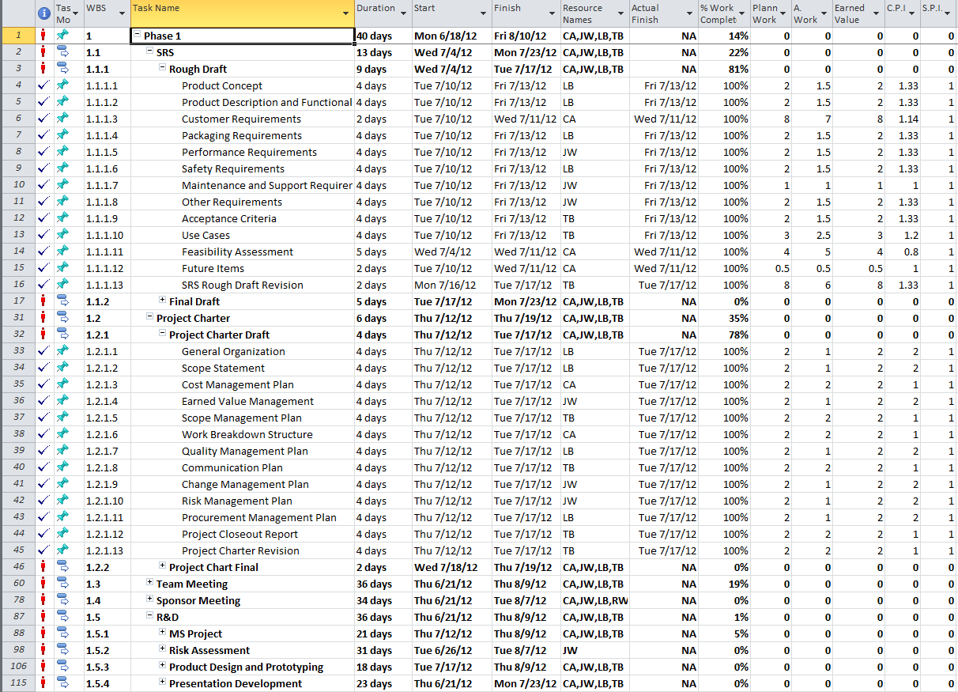

Figure 6-2 shows the project planning of phase 2

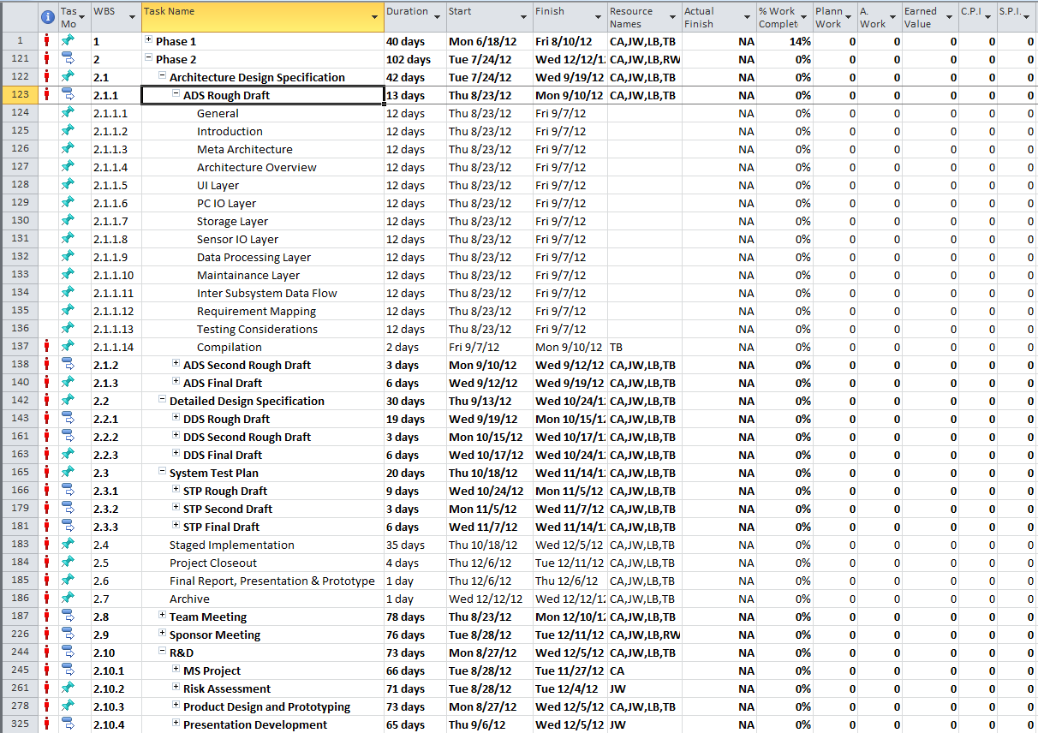

# Quality Management Plan

## Overview

A quality management plan ensures that through the development phase the product continues to meet requirements and acceptance criteria. The quality management plan for The Builders Group involves the following steps:

* Component Testing
* Integration Testing
* Formal & Informal Test Plans
* Access to Previous Test Results

Component testing will be completed by the Developer and is required in order for the component to be considered completed. This will follow an informal test plan of the Developer’s design. A brief summary of tests performed and results obtained will be provided to the Quality Manager upon completion.

Integration testing will be completed by a Test Engineer as assigned by the Quality Manager. It will test the functionality of components as they are brought together into a working whole. Only one component will be added to the system at a time; after it has passed integration testing, more components may be added. This will help to minimize troubleshooting.

Formal and informal test plans will be created by both the Quality Manager and the developers. The plans will delineate the manner of testing to be done on the components and product. The results of executing these plans will be reported to the Quality Manager for recording. Test plans will cover areas such as: boundary conditions, error conditions, invalid input, and stress testing.

Test results previously submitted to the Quality Manager will be maintained by the same in the project’s online code repository for access by The Builders Group team at any time.

## Roles and Responsibilities

Throughout the project, there will be three roles associated with quality management: the Quality Manager, the Developer, and the Test Engineer. The responsibilities of each are listed in Table 17-1 below.

Table 5 - Quality Management Roles and Responsibilities

|  |  |  |
| --- | --- | --- |
| Role | Responsibilities | Assigned Personnel |
| Quality manager | * Inquire about testing progress/issues of completed components * Help generate formal and informal test plans * Track component testing results for future reference * Report any findings and keep the group apprised of known bugs and flaws * Ensure product development continues to take into account the acceptance criteria * Assess priority of findings and allocate resources to address as necessary | Lloyd Bond |
| Hardware, Software, Platform Developers | * Generate informal test plans with Quality Manager’s assistance as necessary * Test individual components before submission as complete * Inform Quality Manager of testing generalities and any issues encountered | Chudamani Aryal, Lloyd Bond, Tyler Buchanan, Jefferson White |
| Test Engineer | * Follow formal test plans * Perform integration testing * Inform Quality Manager of results of testing and any issues encountered | Chudamani Aryal |

# Communications Plan

## Summary

The communications plan indicated here will be followed by all team members throughout the life of the project. The plan indicates policy and procedures for primary and secondary means of communication through the use of technology. The Communications Plan can be altered in the event that a new communication technology is available, scheduling requires a change, or current communication ability becomes unavailable.

## Internal Communications

This section indicates how team members will communicate with each other.

### Meetings

Team meetings will be held on Tuesday, Thursday, and Fridays immediately following Senior Design lectures and during labs. Meetings held on Tuesdays and Thursdays will be held for one hour due to students having classes that follow. Friday’s meeting will last for 30 minutes to discuss topics of interest and updating team members on upcoming events. The team leader will be held responsible for setting and keeping the agenda for all meetings. In the event that an emergency arises, the team leader will issue a mandatory emergency meeting which all team members must be available for either by instant messaging, email, video conference, or in person. The records of the meetings shall be maintained by Lloyd Bond.

### Phone

Members of The Builder’s Group Ltd will use phones for conversations that require immediate response or when emails are improperly working. Phones will be used if necessary for reminders or emergencies only. Unless internet is unavailable, phones will not substitute any other communication that can be tracked.

### Emails

Emails will be the primary means of communication for the team. This is the easiest method as everyone has access to an email account. Emails also provide the ability to track conversations and progress through the design of the project. Emails will also be used to share documents that are not appropriate in our documents repository.

### GitHub

GitHub will be used as a secondary communications device. Since this is also our file sharing server that contains everything from team member availability to high level deliverables. When posting to the file server, GitHub also has the option of leaving a message in a comment box when posting files. This is not a primary means of communication but can be used if necessary.

## External Communications

This section will describe how communication with outside members will take place.

### Sponsor

The Builders Group Ltd will contact the project sponsor via email and during his lab hours. Meetings with the sponsor will be conducted when problems arise, when requirements need to be described in more detail, and/or when the project is ready for testing.

### Team Supervisor

The Builders Group Ltd will need to maintain contact with the team supervisor in order to maintain focus or incase questions may arise. Communication by email will be the primary method of contact for the team supervisor as we have the possibility of tracking and including any possible conversations into the final project file for future reference.

# Change Management Plan

## Purpose of an Integrated Change Management Plan

There is an extremely high (almost inevitable) chance for necessary changes to arise during the course of this project. These may be caused by changes to the set schedule, changes to the available budget, changes in customer requirements as well as other changes. Adapting to these changes is important to ensure project success and completion acceptance by all stakeholders. However, there will also arise some proposed changes that will not be necessary for the completion of the project. Therefore it is important to set out a system that can manage the proposed changes.

The change management plan is also important so that all stakeholders know the status of such changes, and all changes can be tracked and handled correctly. This will include analyzing the change, controlling the impact, and dealing with the effects. Changes can come from many sources, including all stakeholders of the project.

## Roles and Responsibilities

*Project Sponsor:* The project sponsor is acting as the customer for this project, so their role in the change management plan is very important. The sponsor represents the source of any changes to the project by the customer, so will be able to propose changes for consideration. The sponsor will also be requested to approve all changes to the project.

*Project Manager:* The project manager maintains the schedule of the project and so will be responsible for presenting and leading the analysis of any changes related to the project schedule.

*Change Manager:* The change manager is responsible for documenting status, impacts and effects of any change brought to the team.

*Project Team:* All proposed changes to the project shall be presented to the project team for deliberation. The team shall meet as a whole to discuss the impact of the change and any other considerations necessary to address the change.

## Review and Approval Process

Any change presented to the team will be recorded and discussed as an item at the next scheduled team meeting. The change manager will lead the analysis of the change emphasizing the impacts of the change. After discussion, if the team decides to go forward with the change, a plan to do so will be set out. The change will be presented to the sponsor for final approval before enacted upon.

## Change Identification, Documentation, Implementation and Reporting

When a change is identified, the person requesting the change will be responsible for filling out a change request form. This form will be given to the Change Manager who will file it in a binder. The person filing the form will be responsible for providing various pieces of information including, but not limited to: source of the change, reason for the change, a description of the change, estimated cost for the change, and possible systems affected by the change. All members will use this information to determine the feasibility of implementing the proposed change. The form will be used to document additional information such as estimated impact on the project, the disposition, the plan to enact the change, and any other information that pertains to the change. All submitted forms will be kept in a binder.

In addition to the hard copies in the binder, there will be a change spreadsheet kept on OneNote that will allow the team to quickly view and update information regarding each change. This will be for reference only and will allow the team members to make comments regarding the status of a change.

Once all the research have been conducted, all members will decide whether to include the change or not. The Change Manager will finalize the change. Then the Project Leader and Project Sponsor will have to approve it.

# Risk Management Plan

## Purpose of Risk Management Plan

All stakeholders involved in this project recognize that the project itself comes with certain risks. Some of these risks are common ones that can be associated with most projects, and some are more specific to the scope of this particular project. It is important to identify and plan for as many of these risks as possible because they can all affect the schedule or budget of the project as well as the overall success.

The Risk Management Plan is the method used to systematically identify, assess and control risks identified with this project. It will help avoid any risks if possible, and minimize negative effects of unavoidable risks on the success of the project.

## Roles and Responsibilities

*Project Sponsor:* The project sponsor will identify any risks to the project that they may be concerned about, and provide them to the team for analysis. The sponsor may also be involved with the team in controlling the risks if possible.

*Project Manager:* The project manager, as a member of the team, will help identify risks with the team. The manager will have the final decision of prioritization of identified risks after consideration with the rest of the project team.

*Risk Manager:* The risk manager will lead the team during risk assessment. They will keep track of any risks identified by either the team or the sponsor. The risk manager must also plan for any risks identified, with input from the project team. Finally, they will be in charge of monitoring all identified risks throughout the project, which will involve discussing them with the team regularly during meetings.

*Project Team:* The project team will assess all risks together as a group. All members must report any risks that they have identified and provide meaningful analysis during this process. They will also monitor the risks, with the help of the risk manager, to detect any of the identified risks that occur during the project.

## Risk Identification

Risk identification is when any stakeholder contributing to the risk management presents any foreseeable potential problem with the project or development process. Identification includes listing the potential risk in detail so it can be thoroughly analyzed with respect to the project. All risks that have been identified will be recorded by the risk manager. Multiple tools to be utilized during risk analysis include:

- Past project experience,

- Documentation of common project problems which are then related to this project

- Input from project stakeholders, including team sponsor

## Risk Triggers

Some observable risk triggers that can serve as warning of certain risk occurrences include:

* Addition of new requirements
* Changes to existing requirements
* Deliverables or mini milestones not being met on schedule
* Poor morale
* Poor cost performance index

## Risk Analysis

Risk analysis provides a means to examine all risks identified, and helps stakeholders better understand risks. A sample of analyzed risks for this project follows:

Table 6 – Product Risks

|  |  |  |  |
| --- | --- | --- | --- |
| Name | Priority(1-5) | Likelihood(%) | Size of loss (weeks) |
| Doesn't float | 1 | 40 | 3 |
| Extreme Temp Failure | 1 | 40 | 3 |
| Frame Resilience | 4 | 30 | 2 |
| Project Failure | 1 | 30 | 4 |

Table 7 – Personnel Risks

|  |  |  |  |
| --- | --- | --- | --- |
| Name | Priority(1-5) | Likelihood(%) | Size of loss (weeks) |
| Personnel Availability | 4 | 80 | 2 |
| Lack of Buy-in | 5 | 20 | 3 |
| Burnout | 1-2 | 95 | 2 |
| Sponsor Availability | 5 | 50 | 2 |

Table 8 – Process Risks

|  |  |  |  |
| --- | --- | --- | --- |
| Name | Priority(1-5) | Likelihood(%) | Size of loss (weeks) |
| GPS Integration | 5 | 30 | 1 |
| Hardware Failure | 3 | 40 | 1 |

## Risk Severity

In order to analyze the severity of risks, they are compared against each other to give a Risk Severity Grid. Risks are ordered by severity, which is calculated as the product of the likelihood and size of loss identified during qualitative and quantitative analysis. The risk severity grid follows:

Table 9 – Risk Severity

|  |  |
| --- | --- |
| Name | Severity (likelihood x size of loss) |
| Burnout | 1.9 |
| Personnel Availability | 1.6 |
| Doesn't float | 1.2 |
| Extreme Temp Failure | 1.2 |
| Project Failure | 1.2 |
| Sponsor Availability | 1 |
| Frame Resilience | 0.6 |
| Lack of Buy-in | 0.6 |
| Hardware Failure | 0.4 |
| GPS Integration | 0.3 |

## Risk Response Planning

The team will make every attempt to avoid risks or minimize effects if those risks are encountered. A plan is set out in response to each risk to ensure that they can be controlled effectively. The plan for each identified risk during this project follows:

Table 10 – Risk Planning

|  |  |
| --- | --- |
| Name | Response |
| Burnout | All team members will maintain focus and stay involved with project. |
| Personnel Availability | This risk is accepted, and backup roles are assigned for major roles. Also members are committed to provide assistance for transportation problems. |
| Doesn't float | Research will be done before and during design. |
| Extreme Temp Failure | Research to ensure product operating temperature is below required threshhold. |
| Project Failure | Research and attention to details during design will minimize likelihood of this risk. |
| Sponsor Availability | Regular meetings with sponsor are planned to minimize any periods when they may not be available. |
| Frame Resilience | Research will be done to ensure materials used are resillient. Also care will be taken during handling of the product. |
| Lack of Buy-in | All members will have major say in development of project to ensure complete buy-in. |
| Hardware Failure | Research of reliable hardware components will be done. Backups of some items may be purchased if budget allows it. |
| GPS Integration | Accepted, due to low priority. |

## Risk Documentation and Reporting

The risk manager will maintain all risks on the team GitHub repository. All analysis and planning of risks will be kept here. The risk manager will also report his ongoing risk monitoring status at weekly meetings, and keep this information in the repository.

## Risk Control

The risk manager is responsible for monitoring the risks throughout the project. He will confer with team members during weekly meetings to identify any triggers that may have occurred. The risk manager will also check with the team to make sure the actions to control each risk are being completed.

During team meetings, team members will identify any new risks, or changes to already identified risks. The team will then analyze the new information together and the risk manager will add the item to the risk repository. This also applies to any new or changed risks identified by the sponsor.

# Procurement Management Plan

## Purpose of the Procurement Management Plan

Procurement is the process of acquiring anything tangible or intangible requiring expenditure charged against the project budget. An efficient plan will accomplish the following:

* Identify the purchasing needs of the project including:
  + individual products and services
  + the purchasing timing requirements
* Establish a procurement policy
* Establish purchase monitoring practices that

## Roles and Responsibilities

Table 11 – Procurement Roles and Responsibilities

|  |  |  |
| --- | --- | --- |
| Role | Responsibilities | Assigned Personnel |
| Project Sponsor | * Make purchasing approvals | Dr. Roger Walker |
| Team Supervisor | * Make purchasing approvals | Mr. Mike O’Dell |
| Procurement Manager | * Work with Lead Architect to identify project procurement needs * Perform procurement cost analysis * Obtain procurement approval * Track purchase orders * Report completed purchases | Lloyd Bond |
| Integration Lead | * Work with Procurement Manager, Hardware Architect, Software Architect, Platform Architect to identify purchasing needs | Chudamani Aryal |
| Team Members | * Perform procurement identification as necessary according to role | Chudamani Aryal, Tyler Buchanan, Jefferson White, Lloyd Bond |

## Required Project Procurements and Timing

The Procurement Manager will work with the team Architects during the architectural design phase of the project to identify the requirement project procurements and their appropriate timings.

## Description of Items/ Services to be acquired

This section of the Procurement Management Plan will provide a tentative list of items that will be ordered from external sources to complete the project. These items include:

* Inclinometer
* PIC microcontroller
* One Chip solution Ethernet interface (I2C, SPI)
* Light material platform
* Distance Encoder
* Various Hardware
* Various discrete circuit components
* Temp Sensor

Others TBD

# Project Closeout Report

## The following are suggested sections for the Project Closeout Report:

## Purpose of Closeout Report

After the project is completed, a Closeout report will be created. The closeout report insures that personnel, contract, administrative, and financial issues are resolved, that documents are archived, and lessons learned are captured.

## Administrative Closure

### Were the objectives of the project met?

The Closeout Report will include a section describing the success or failure of the project compared to the System Requirements Specification. Each requirement will be analyzed and graded based on whether objectives were met. Testing on-site will also serve as a measurement of success for the team members and if passing will be the effect of successfully meeting the requirements. If any deviations from the baseline requirements and final product then they will be described here.

### Archiving Project Artifacts

All project documents will be collected in the team GitHub fileserver and compiled into a single folder. All documents from financial records to contract files will be located here for future reference. The team leader will be responsible for creating backup copies of all files and creating the archived folder.

### Lessons Learned

Upon completion of the device, the team will conduct a lessons learned session where they will discuss and record each members opinion on what could have worked better, ways of improving, and what did not work. All discussions will be recorded by the team note taker and included in the project archive.

### Plans for Post Implementation Review (PIR)

Through the final phase, team members will complete a PIR which includes whether or not the project met their expectations and feels the final design is satisfactory. Performance may also be measured on system requirements that were met and if the project passed the live demonstration.

### Final Customer Acceptance

Customer Acceptance will be a requirement throughout the lifetime of this project. Customer acceptance will be validated through a live demonstration. The sponsor will sign off on the final agreement that the project was completed as specified through requirements and that the device performs satisfactory through the live demonstration. If open issues remain, a meeting with the sponsor will take place to decide the best route in order to correct the issue. If the issue can be avoided by scrapping a feature then that possibility will be voted on.

### Financial Records

All financial record documents will be maintained by the financial officer which includes invoices, purchase orders, and final cost reporting. All purchases will be reviewed by the team for acceptance or possible alternatives. The final cost records will be archived in the project archive folder found on the team GitHub Fileserver.

### Final Project Performance Report

Once the project is completed, a Final Project Performance Report will be conducted which summarizes the project’s scope management, scheduled performance, cost performance, quality achievements, and a review of the risk containment performance. If any reason there is a cost or schedule variance, then reasoning will be included as well as the project sponsors approval.